**A Project Report on**

**Finding out the Telephone Bill of Customers with Security Access**

Submission of

**Course CSE-100: Software Development Project-1**

By

**Md. Montasir Amin** **Mostafa Ahmed An-Nur**

**Roll: 17102033** **Roll: 17102024**

**Submission Date: April 2, 2018**



Department of Computer Science & Engineering

**Jatiya Kabi Kazi Nazrul Islam University**

**Supervised By :**

**Kazi Mahmudul Hassan**

Lecturer,

Dept. of CSE, Jatiya Kabi Kazi Nazrul Islam University.

The undersigned have examined the report entitled “**Finding out the Telephone Bill of Customers with Security Access**” presented by **Md. Montasir Amin**, a member of course **CSE-100: Software Development Project-1** group and hereby certify that it is worthy of acceptance.

02-04-2018 **Kazi Mahmudul Hassan**

Date Advisor’s name

02-04-2018 **Mostafa Ahmed An-Nur**

Date Group member name

Dedication

Dedicated to: **Our Honorable Teachers.**

# ABSTRACT

## **PSTN**(Public Switched Telephone Network) or Landline is popular since earlier century. Till now, most of the official task or institutional functions are going on with this PSTN or Landline Telephone network. In our project we have fixed our action on calculating the different types of call duration with their rate including vat and monthly rate of a consecutive number of customers one by one. The software project also presents the current date and time after entering the valid username and password. After neglecting all invalid or illegal data input and taking relevant information from customer it outputs us a customer’s total specific monthly telephone bill that he has to pay. Whenever any customer enters any wrong access permission or wrong data value it displays error and claims the correct information again. “Finding out The Telephone Bill of Customers with Security Access” is the project that helps us for calculating a customer’s specific monthly telephone bill. It is noted that, we have developed our software project based on RanksTel operator which is defined as a fixed line PSTN operator.

**Advantages of this software are as below:**

* Someone can easily calculate his monthly telephone bill.
* Eliminates the limitations of manual calculations.
* The software alerts the customer the instant time while executing.
* Features of data validations help the authority from inserting illegal or invalid data.
* The software takes the current date automatically.
* Authority can handle more than one customer’s calculations in a single start up of the software.

# ACKNOWLEDGMENTS

First and foremost, I would like to express my gratitude to Allah, the most gracious and the most merciful, for allowing me to complete this work. And then I would like to thank to my **Supervisor KAZI MAHMUDUL HASSAN,** lecturer, Department of Computer Science & Engineering, Jatiya Kabi Kazi Nazrul Islam University, Trishal, Mymensingh for his helpful suggestions in selecting my project topic, planning and implementing the work. Also he greatly helped me in improving my report writing and presentations, which, obviously, will guide me throughout my future life. I would like to give my special thanks to my parents and friends.

We wish to express thanks to **Engineer A.H.M Kamal**, Head, Department of Computer Science & Engineering, Jatiya Kabi Kazi Nazrul Islam University for providing us lab opportunities with lab materials related to our project work.

We also thank all of our friends, group member & lab assistant and our family for helping to complete the project **“Finding out The Telephone Bill of Customers with Security Access”**.

Finally, we express our thanks to the Department of Computer Science and Engineering for giving us the opportunity to study here and supporting us greatly through our graduate study.

Table of Contents

ABSTRACT iv

ACKNOWLEDGMENTS v

LIST OF FIGURES viii

**CHAPTER 01: INTRODUCTION** 09

1.1 Introduction 09

1.2 Background Study 10

1.3 Our Approach 10

1.4 Objectives 11

1.5 Key Features of Proposed System 12

1.6 Key words of Proposed System 12

1.7 Organization of This Report 13

**CHAPTER 02: Software Overview** 14

2.1 Motivation 14

2.2 Tools 14

2.3 Overview Of The Software 16

**CHAPTER 03: Finding out the Telephone Bill of Customers with Security Access** 17

3.1 Pictorial Description 18

**CHAPTER 04: Program Analysis and Design** 21

4.1 Flowchart 21

4.2 State Diagram 22

4.3 How it works 23

4.4 Data validation 23

**CHAPTER 05: RESULT AND DISCUSSION** 24

5.1 Limitations 24

5.2 Further Development(future work) 24

5.3 Result & Discussion 26

# LIST OF FIGURES

Figure 1: Fixed Line Telephone. 09

Figure 2: RanksTel company Logo. 10

Figure 3: Telephone Billing System 11

Figure 4: Code :: Blocks IDE. 14

Figure 5: C language theme 15

Figure 6: C language symbol 15

Figure 7: screenshot1 18

Figure 8: screenshot2 18

Figure 9: screenshot3 18

Figure 10: screenshot4 18

Figure 11: screenshot5 19

Figure 12: screenshot6 19

Figure 13: screenshot7 19

Figure 14: screenshot8 19

Figure 15: screenshot9 20

Figure 16: **Flowchart of the Project** 21

Figure 17: **State Diagram of the Project** 22

Figure 18: Search Icon 24

Figure 19: Storage Memory Icon 24

Figure 20: A Colour Printer 25

Figure 21: Symbol for Web Connectivity 25

# CHAPTER01: INTRODUCTION

# 1.1 Introduction:

Since last century, Telephone is performing a great job in our everyday’s communicative-life. At present, along with a few Mobile Network Operators i.e.: GRAMEENPHONE, BANGLALINK, ROBI etc there are also some Fixed line network operators i.e.: BANGLA PHONE, TELEBARTA, RanksTel, BIJOY PHONE etc.”Finding out the Telephone Bill of Customers with Security Access” is the project that helps us to calculate individual customer’s total call duration of a specific month after granting correct username and password. It also calculates the cost of total call in Taka considering the monthly rent and also the vat. It is also to be noted that, while executing the software it shows us the current time and date. Finally after taking all input values that relevant to the customer it shows us the exact total amount that the customer has to pay for that month.

Whenever any illegal user or customer enters any wrong or invalid data the program shows him error and asks for the valid information again. This program can count maximum Customer no: 1000000’s individual calculation and each type of the minute type should not exceed up to 100000 minutes. In the approach of customer name and address each string should not exceed 10 characters and Telephone number should take only the last 8 digits associated with RanksTel operator.

**Pre-provided data values are as follows:**

**Monthly rent:** 100Tk; **LOCAL call rate:** 1.5Tk/min; **ISD call rate:** 6.0Tk/min; **NWD call rate:** 3.5Tk/min; **VAT:** 30% of total cost.

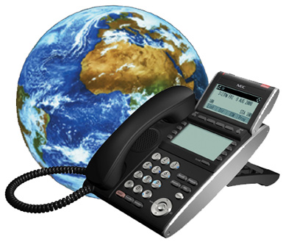

FIG 1: Fixed Line Telephone.

# 1.2 Background Study:

In distance wireless communication there are two types of device. Mobile network operator and Fixed line network operator. Different types of fixed line network operators are available in the market. We have focused on RanksTel operator which is fixed line network operator as PSTN.



FIG 2: RanksTel Company Logo.

**RanksTel uses the following numbering scheme:**

+880 44 R1R2R3R4R5R6R7R8

+880 is the [International subscriber dialling](https://en.wikipedia.org/wiki/International_subscriber_dialling) Code for Bangladesh.

44 is the BTRC allocated code for RANKSTEL. Considering local dialing, 044 will be the general prefix

R1 is the Division wise local code for RANKSTEL.

R2 is the Package identification number for the subscriber of RanksTel.

R3 to R8 is Subscriber identification number for RanksTel.

Basically, based on RanksTel operator we have developed our console based software to calculate a customer’s monthly Telephone Bill.

# 1.3 Our Approach:

First, we studied about Telephone Billing of fixed line connection from online and developed our project. The project can overcome all the limitations of the existing system. The system provides proper security and reduces the manual work. The system is very simple in design and to implement. The system requires very low system resources and the system will work in almost all configurations.

# 1.4 Objectives:

Manually it is very difficult to calculate the total minute of a telephone bill along with individual customer’s relevant information and total cost of the customer counting the monthly rent and vat. With the help of computer it becomes easy and faster to manage the system. In this project, it is the facilities to take all information and calculate a customer’s specific month total Telephone bill calculation in the system. The main objective of the system is which target to put a security to the user of the software and calculate his monthly total Telephone bill.

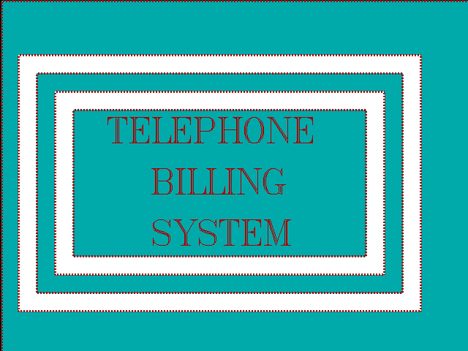

## FIG 3: Telephone Billing System.

# 1.5 Key Features of Proposed System:

**The project will have the following key features:**

* Username and password facility.
* Current date and time notification while executing.
* Automatic date input feature.
* Excellent data validation.
* Can calculate more than one customers Telephone bill in a single start-up.

# 1.6 Keywords:

**The keywords related to our projects are as follow:**

* Executing Time
* User Name
* Password
* Customer No
* Name of the Customer
* Address
* Date
* Telephone number
* Month
* Minutes in Local call
* Minutes in NWD call
* Minutes in ISD call
* Call rate in each type of call(Pre added)
* Monthly rent(Pre added)
* VAT(Pre added)
* Total Telephone Bill

# 1.7 Organization of This Report:

This report is organized in four chapters. The introductory information of the project work have already discussed in this chapter.

**Chapter 1: Introduction**

In this part we have introduced what our project is and how it can help a person to calculate a customer’s monthly Telephone Bill .We have also described about what features and facilities in our proposed system will have.

**Chapter 2: Software Overview**

The Telephone Bill of Customers with Security Access is the project which is mainly developed for calculating a customer’s total monthly Telephone cost with relation of His total call duration. It also shows the executing start-up time and date and also considers all data validation.

**Chapter 3: Finding Out the Telephone Bill of Customers with Security Access**

In this section the traditional and conventional ways of software development is described briefly .We also described which development process we followed during the development of this proposed system. The system architecture and model is also included textually and visually. We described the software model through necessary Screenshots in this chapter. Basically, Pictorial description of software project is given in this section.

**Chapter 4: Program Analysis and Design**

We discussed about the specific steps which are taken to develop the proposed system. We represented our software project with Flow chart and state diagram in this chapter. We also explained here about how it works and data validation.

**Chapter 5: Result and Discussion.**

In this section we have discussed and shown the final output of our Software Development Project. We also described about the testing part, scope and limitation, further development.

# CHAPTER 02: Software Overview

# 2.1 Motivation:

After realizing the theme of taking records of monthly total call duration and calculating them with other circumstances with security access in order to get a fluent concept of total cost of bill of a specific month.

# 2.2 Tools:

# (1) We used an IDE named Code::blocks v.17.12 to implement, build and operate the code.

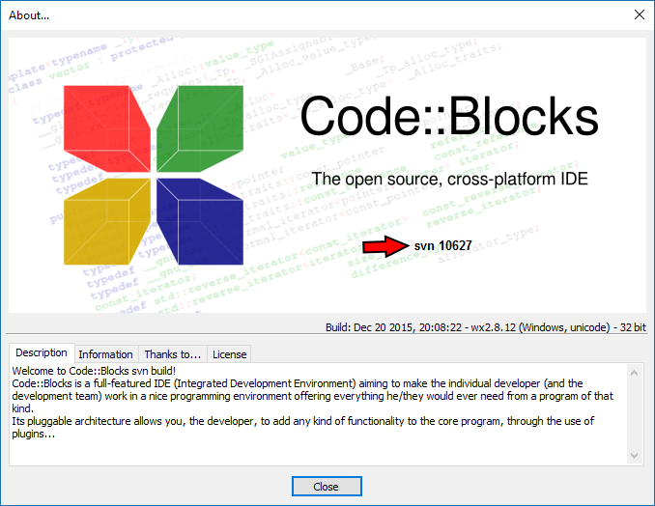

FIG 4: Code::Blocks IDE.

**(2)We took the help of C language to build our software project.**

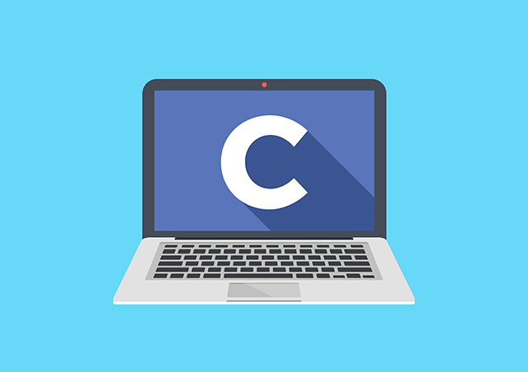 

FIG 5: C language theme FIG 6: C language Symbol

## 

### 

### 

### 

# 2.3 Overview of the Software:

The software we developed here is simple to use. Whenever the authority needs to calculate the customers total telephone bill of a specific month they just have to click the software icon. Then the software will ask them the required username and password. If the authority is legal they will enter the correct username and password and can get access to the main function of the software. The software then shows them the current time and date. Firstly, asking for the customer’s serial number, the program will gradually ask for customer’s name (3 strings), address (3 strings), telephone no, specific billing month. The date is automatically accepted. The software then asks for customers total call duration (Local, NWD and ISD) individually. After taking all data this program calculates them and shows the total Telephone costs of the customer of that month in a nice formation pattern. It is also be noted that, while calculating the total bill the program itself adds monthly rent of Tk. 100 and vat 30% in total cost of calculation. Finally we get the exact cost that the customer has to pay.

# CHAPTER 03: Finding Out the Telephone Bill of Customers with Security Access.

# 3.1 Pictorial Description:

# Our Software project related all necessary screenshots are provided below:

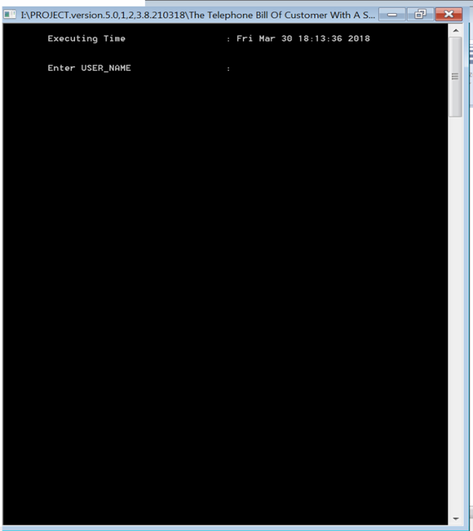 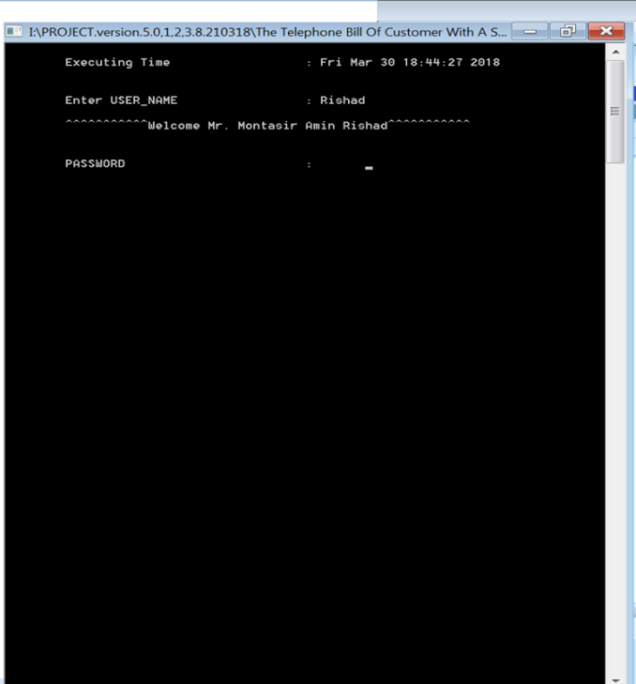

**FIG 7: screenshot1** **FIG 8: screenshot2**

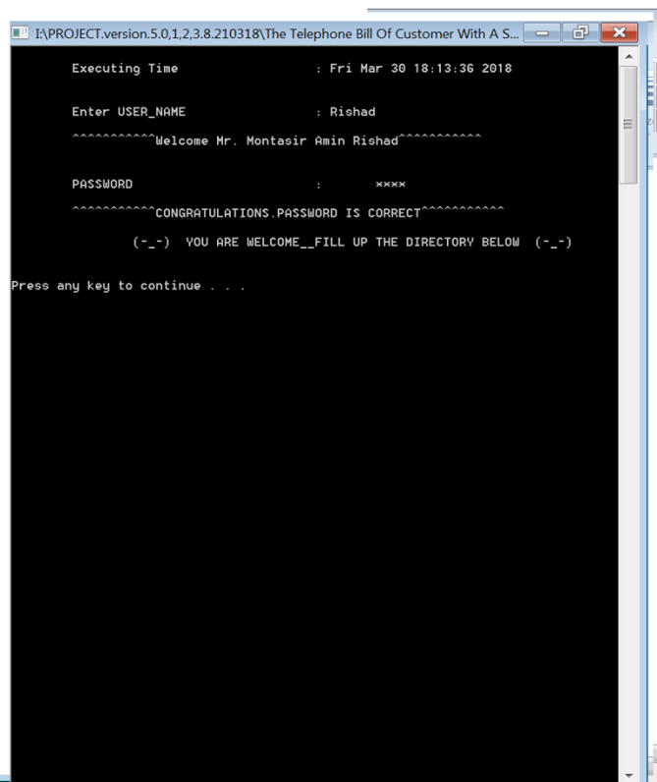 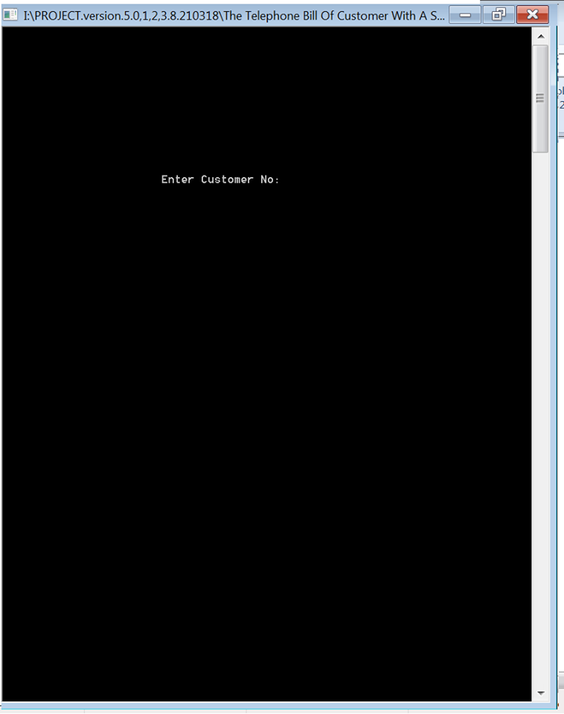

**FIG 9: screenshot3**  **FIG 10: screenshot4**

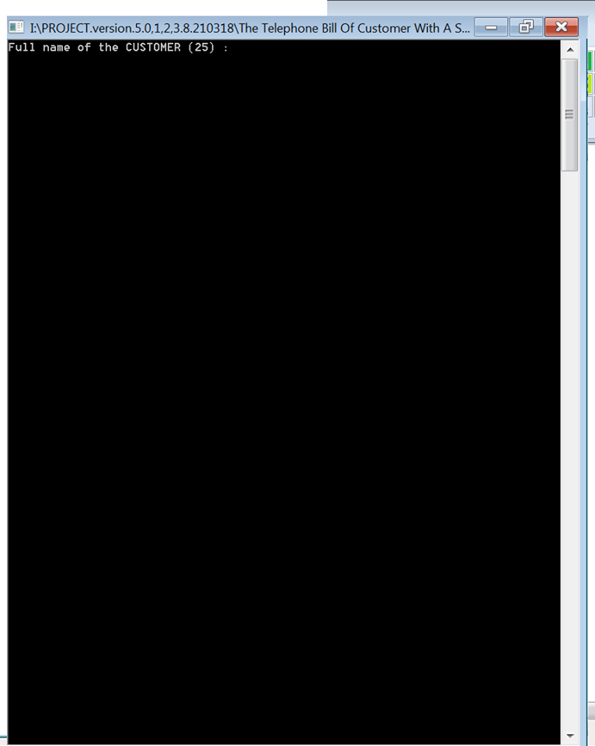 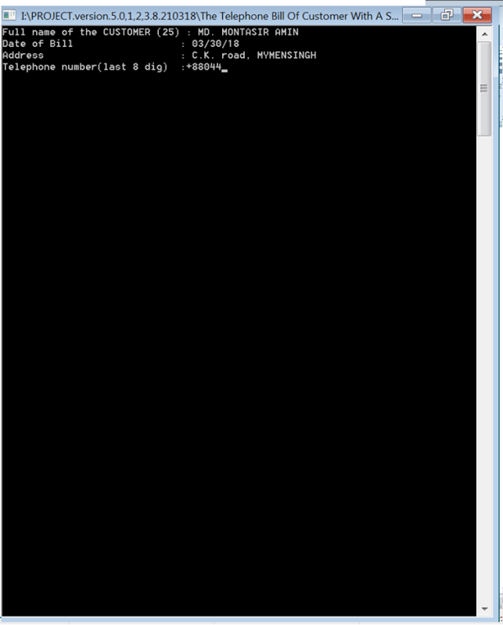

**FIG 11: screenshot5**  **FIG 12: screenshot6**

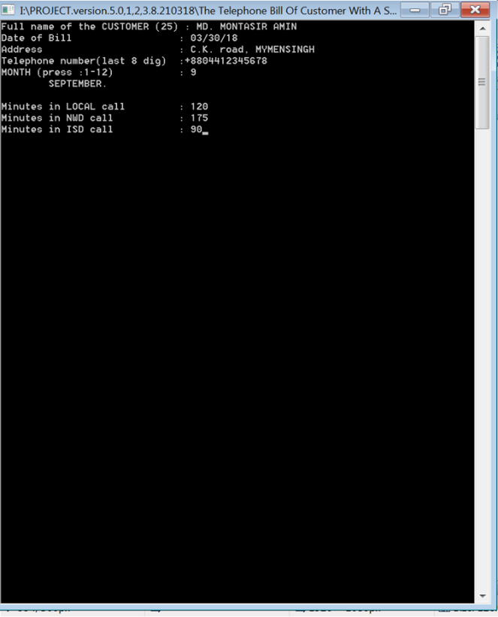 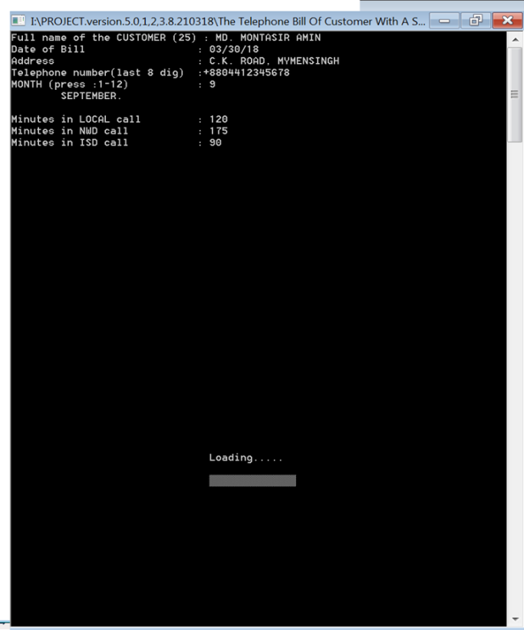

**FIG 13: screenshot7** **FIG 14: screenshot8**

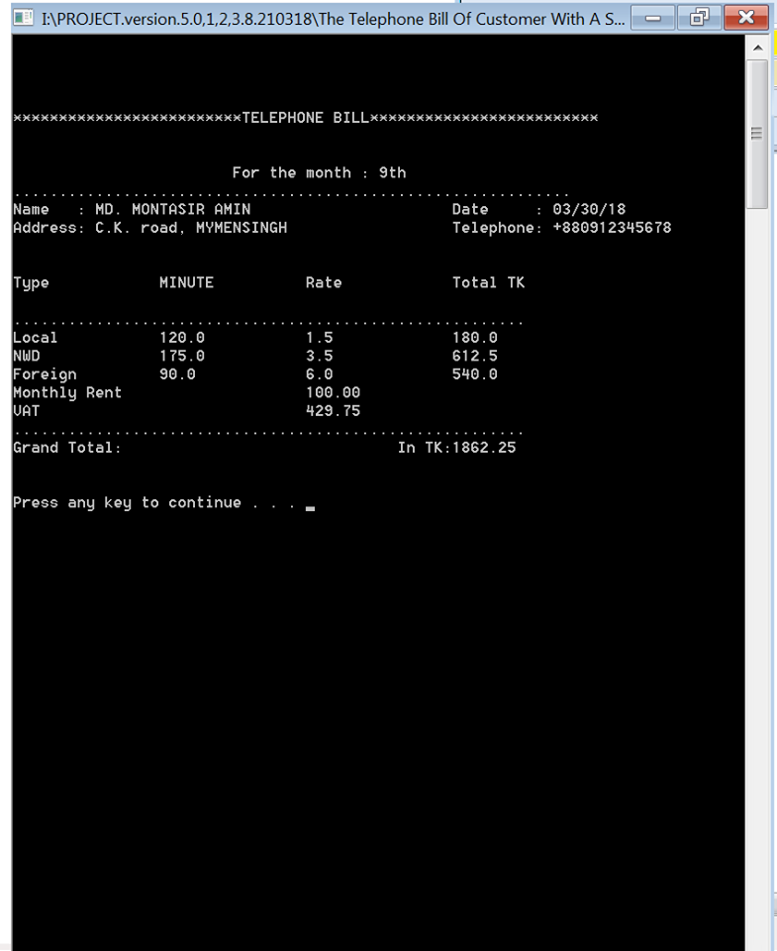

**FIG 15: screenshot9**

# CHAPTER 04: Program Analysis and Design

# 4.1 Flowchart: Finding out the Telephone Bill of Customers.010418.png

**Figure 16: Flowchart of the Project** **(Finding out the Telephone Bill of Customers with**

**Security Access)**

# 4.2 State Diagram:

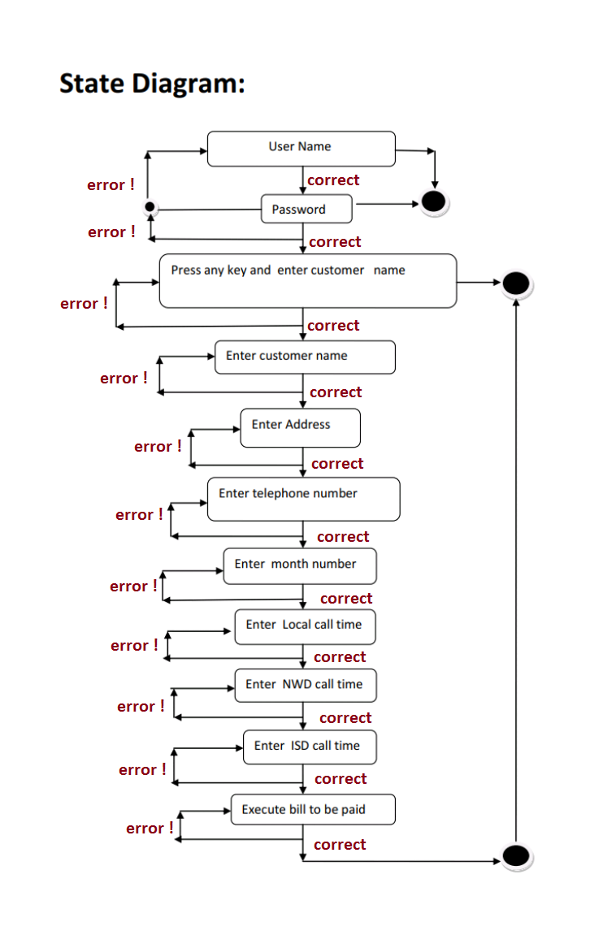

**Figure 17: State Diagram of the Project** **(Finding out the Telephone Bill of Customers with**

**Security Access)**

# 4.3 How It Works:

The project is simple to use. It was developed by c language. With the help of C’s built in function the software is developed. After accessing the grant permission the software asks for the necessary information for processing and calculating total bill part by part. At last calculating all legal value it outputs the final value in a tabular formation.

# 4.4 Data Validation:

The software project also has the feature of data validation. That means whenever you enter any illegal data specially type mistakes it shows error and claims the correct information until it receives the legal data.

**CHAPTER 05: RESULT AND DISCUSSION**

# 5.1 Limitations:

Though the project helps us calculating total bill and saves our time it has some limitations which are described below:

(1)This software is unable to search customer’s name.

(2)It can’t store a customer’s data in a file for the purpose of using them later.

(3)The software is not build up as web connected so that someone can keep web contact through the software.

Though this system has many functionalities it will takes more time to develop at all.

 

FIG 18: Search Icon FIG 19: Storage Memory Icon

# 5.2 Further Development (future work):

Our system has all the functionalities to manage a telephone bill calculation process. But we have some plan to make it more efficient, reliable.

Our expectation is that in future we can make sure to add some important features i.e.:

1. Printer aided interface in this software so that authority can print out the copy of final bill report.
2. Also, we expect to add the facility for searching customer’s name and storing each customer’s all data and information in a file for the purpose of later of later use.

(3) We also expect to add a web base interface in this software project so that one can directly connect to the authority through Web by the help of this software project.

(4) A feature of data analytic.

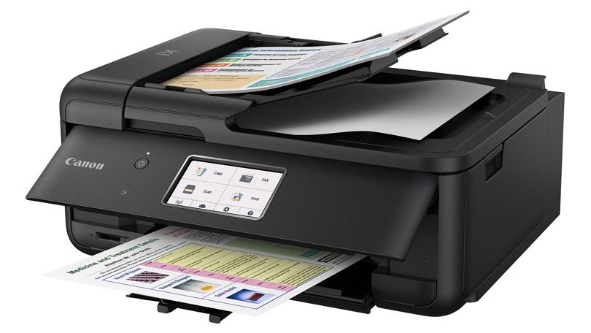 

FIG 20: A Color Printer FIG 21: Symbol for Web Connectivity

# 5.3 Result & Discussions:

We tried to develop the efficient and advance software for calculating the monthly total Telephone bill of a customer. Our system can successfully do calculations and data validations for the customer. It has a very simplified and easy to use user interface. It is a console application and designed to support computer devices, it has different layout for devices having different screen sizes. It is kept secure with a username and default password. It has a nice and ordered architecture. It’s easily understandable and executable. It can save enormous amount of time and energy of the necessary calculations. Also, manual calculations are error prone which can be a great problem, but this system ensures error free calculations. Reports can be generated in seconds and invoice is created dynamically. Besides the existing features and functionalities, it will be more advanced as we have lots of features planned for further development.